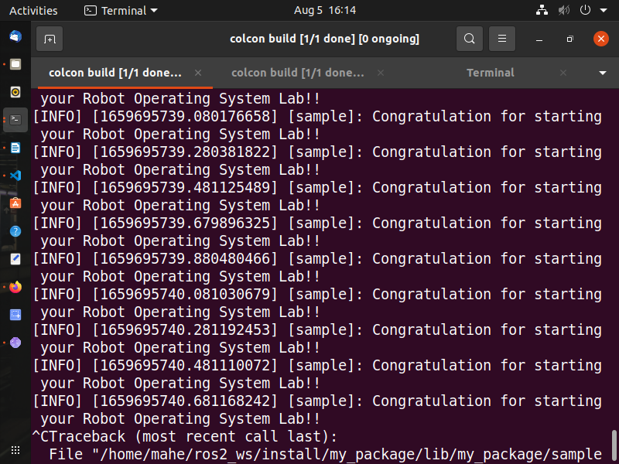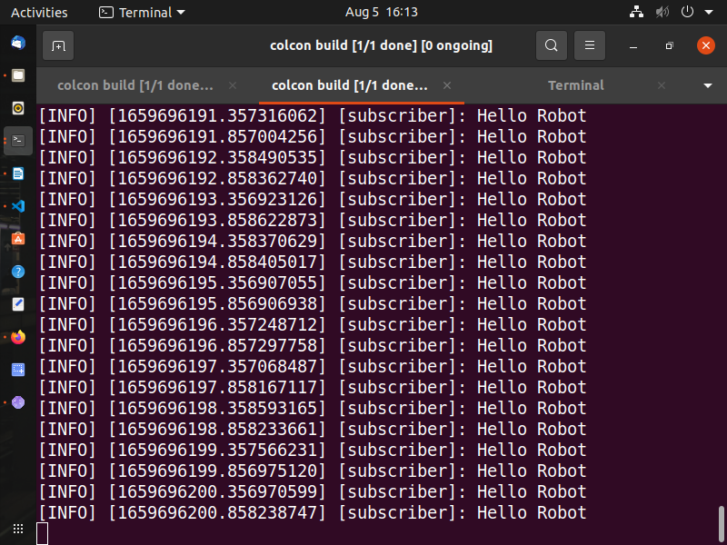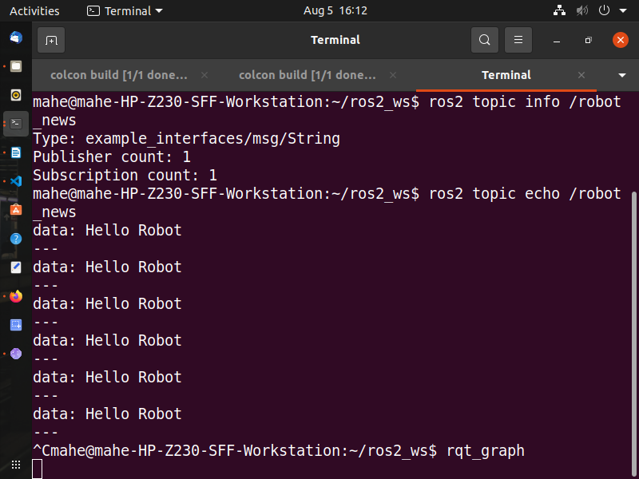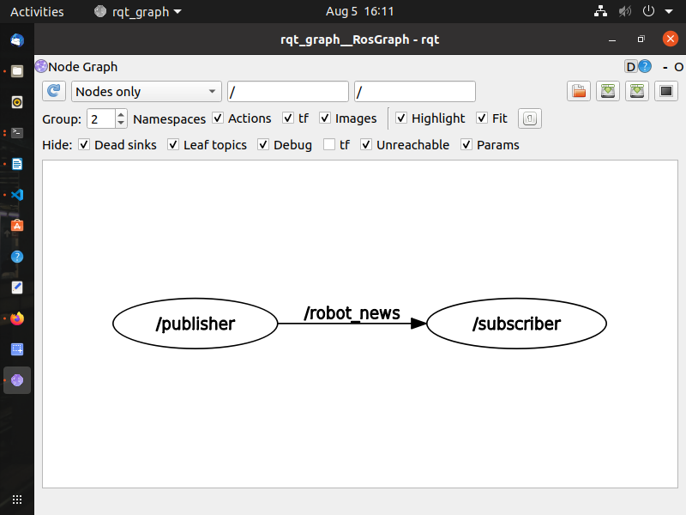

Publisher code for 1Hz message generation

#!/usr/bin/env python3

import rclpy

from rclpy.node import Node

from example_interfaces.msg import String

class RobotPublisher(Node):

def __init__(self):

super().__init__("publisher")

self.robot_name_="ROBOT"

self.publisher_ = self.create_publisher(String, "robot_news", 10)

self.timer_ = self.create_timer(1.0, self.publish_news) #publishes message at 1Hz frequency

self.get_logger().info("Node Started")

def publish_news(self):

msg = String()

msg.data = "Hello " + str(self.robot_name_)

self.publisher_.publish(msg)

def main(args=None):

rclpy.init(args=args)

node = RobotPublisher()

rclpy.spin(node)

rclpy.shutdown()

Subscriber code remains same.